**Credit Card Sales SQL Query**

1. **Credit Card Customer Report**

* **KPI’s**

1. **Total Revenue**

**with revenue as (select * from credit_card union select * from cc_add)**

**select concat(round(sum(Revenue)/1000000,0)," M") as Total_Revenue**

**from revenue ;**

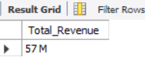

1. **Total Interest**

**with interest as (select * from credit_card union select * from ccadd)**

**select concat(round(sum(Interest_Earned)/1000000,0)," M") as Total_Interest**

**from interest;**

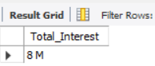

1. **Total Customer**

**select concat(round(count(*)/1000,0)," K") as Total_Customer from customer;**

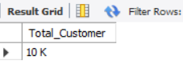

1. **Average Income**

**select concat(round(avg(Income)/1000,0)," K") as Average_Income from customer;**

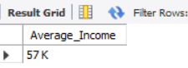

1. **Average Customer Satisfaction Rate**

**with CSS as (select * from customer union select * from cust_add)**

**select round(avg(Cust_Satisfaction_Score),2) as Average_CSS from CSS;**

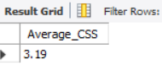

* **Job Category wise Revenue**

**with job as (select * from credit_card union select * from cc_add)**

**select Customer_Job ,concat(round(sum(Revenue)/1000000,0)," M") as Total_Revenue**

**from job join customer on customer.Client_Num = job.Client_Num**

**where Gender = "F" group by Customer_Job ;**

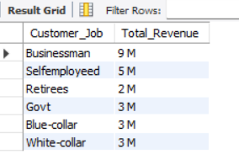

* **Revenue by Education Level**

**with edu as (select * from credit_card union select * from cc_add)**

**select Education_Level ,concat(round(sum(Revenue)/1000000,0)," M") as Total_Revenue**

**from edu join customer on customer.Client_Num = edu.Client_Num**

**where Gender = "F" group by Education_Level ;**

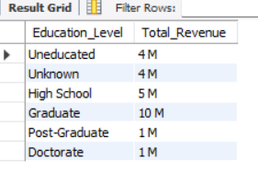

* **Marital Status wise Revenue**

**with marital as (select * from credit_card union select * from cc_add)**

**select Marital_Status ,concat(round(sum(Revenue)/1000000,0)," M") as Total_Revenue**

**from marital join customer on customer.Client_Num = marital.Client_Num**

**where Gender = "F" group by Marital_Status ;**

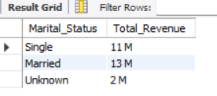

* **Top 5 States by Revenue**

**with state as (select * from credit_card union select * from cc_add)**

**select state_cd ,concat(round(sum(Revenue)/1000000,0)," M") as Total_Revenue**

**from state join customer on customer.Client_Num = state.Client_Num**

**where Gender = "F" group by state_cd**

**order by Total_Revenue desc limit 5;**

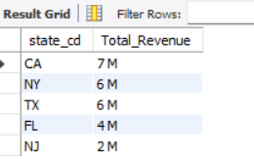

1. **Credit Card Transaction Report**

* **KPI’s**

1. **Total Transfer Amount**

**with amount as (select * from credit_card union select * from cc_add)**

**select concat(round(sum(Total_Trans_Amt)/1000000,0)," M") as Total_Trans_Amt from amount;**

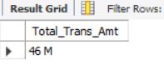

1. **Total Transfer Count**

**with Trans_count as (select * from credit_card union select * from cc_add)**

**select concat(round(sum(Total_Trans_Vol)/1000,0)," K") as Total_Trans_Count from Trans_count;**

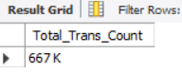

* **Revenue by Card Category**

**with category as (select * from credit_card union select * from cc_add)**

**select Card_Category ,concat(round(sum(Revenue)/1000000,0)," M") as Total_Revenue from category group by Card_Category;**

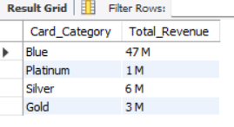

* **Quarterly Revenue by Male and Female**

**with Rev_Month as (select * from credit_card union select * from cc_add)**

**select qtr,concat(round(sum(Revenue)/1000000,0)," M") as Total_Revenue**

**from Rev_Month join customer on customer.Client_Num = Rev_Month.Client_Num where Gender = "F" group by qtr ;**

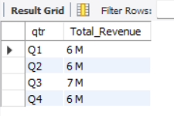

* **Revenue by Use Chip**

**with chip as (select * from credit_card union select * from cc_add)**

**select `Use Chip` ,concat(round(sum(Revenue)/1000000,0)," M") as Total_Revenue from chip group by `Use Chip`;**

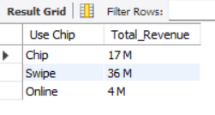

* **Monthly Revenue**

**with Rev_Month as (select * from credit_card union select * from cc_add)**

**select monthname(Date) ,concat(round(sum(Revenue)/1000000,0)," M") as Total_Revenue from Rev_Month group by monthname(Date);**

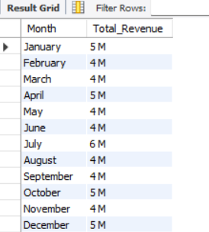

* **Total Expenses**

**with exp as (select * from credit_card union select * from cc_add)**

**select `Exp Type` ,concat(round(sum(Revenue)/1000000,0)," M") as Total_Revenue from exp group by `Exp Type`;**

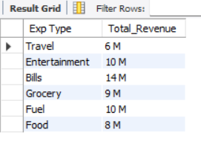

* **Annual Fees by Card Category**

**with fee as (select * from credit_card union select * from cc_add)**

**select Card_Category ,concat(round(sum(Annual_Fees)/1000,0)," K") as Total_Revenue from fee group by Card_Category;**

